**Batch: C1**

**Roll No.: 16010122221**

**Experiment / assignment / tutorial No. 01**

**Grade: AA / AB / BB / BC / CC / CD /DD**

**Signature of the Staff In-charge with date**

Experiment No. 1

**TITLE:** Study of Networking devices (Hub, router, Gateway, Switch etc.) and Transmission Media

**AIM:** To study different Networking devices and transmission media used in day to day networks.

## Expected Outcome of Experiment:

**CO1:** Explain the fundamentals of the data communication networks, reference models, topologies, physical media, devices, simulators and identify their use in day to day networks

## Books/ Journals/ Websites referred:

1. A. S. Tanenbaum, “Computer Networks”, Pearson Education, Fourth Edition
2. B. A. Forouzan, “Data Communications and Networking”, TMH, Fourth Edition

**Pre Lab/ Prior Concepts:** Basics of LAN and Connecting devices

**New Concepts to be learned:** Layer wise connecting devices

## Stepwise-Procedure:

.

## Study of Connecting Devices

1. **Hub**:

* A hub is a basic networking device that connects multiple Ethernet devices together, typically operating at Layer 1 (physical layer) of the OSI model.
* It works by broadcasting data to all devices connected to it, regardless of whether the data is intended for a specific device or not.
* Hubs are not very efficient because they do not manage traffic, leading to potential collisions and slower network performance.

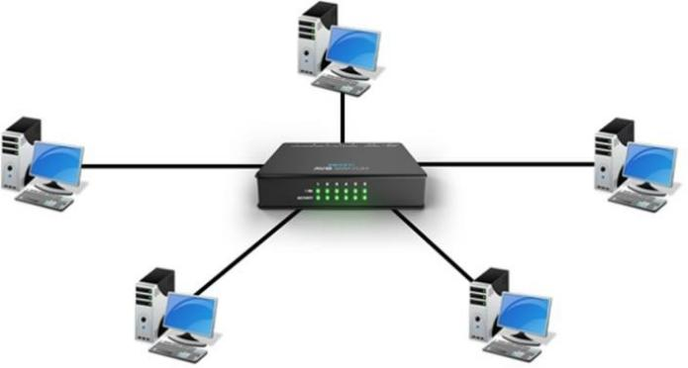

## Repeater:

* A repeater is used to extend the range of a network by regenerating signals received from one segment and transmitting them to another.
* It operates at the physical layer and helps overcome signal degradation over long distances in wired and wireless networks.



## Switch:

* A switch is a more advanced version of a hub, operating at Layer 2 (data link layer) of the OSI model.
* It connects multiple devices in a local area network (LAN) and forwards data only to the specific device for which the data is intended, based on the device's MAC address.
* Switches improve network efficiency by reducing collisions and optimizing bandwidth usage.

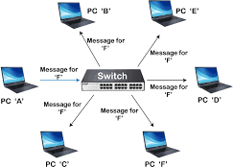

## Bridge:

* A bridge connects two or more network segments and operates at the data link layer (Layer 2) of the OSI model.
* It filters and forwards data between segments based on MAC addresses, effectively dividing a large network into smaller segments to improve performance.
* Bridges help reduce network traffic and isolate network problems.

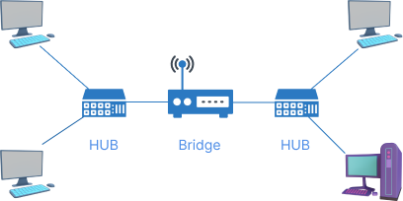

## Router:

* A router is a networking device that forwards data packets between computer networks, typically operating at Layer 3 (network layer) of the OSI model.
* It connects different networks (LANs and WANs) and uses routing protocols to determine the best path for forwarding data.
* Routers can perform network address translation (NAT), which allows multiple devices to share a single public IP address.

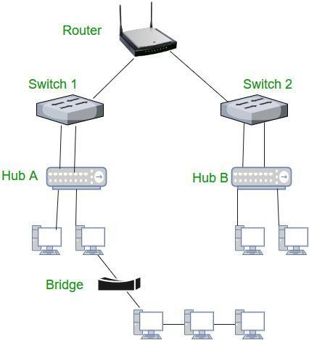

## Gateway:

* A gateway is a device that acts as an interface between two different networks, translating protocols so that devices on one network can communicate with devices on another network.
* It operates at the application layer (Layer 7) of the OSI model and can perform protocol conversions as well as data format transformations.
* Gateways are often used to connect a local network to the internet or to link networks with different communication protocols.

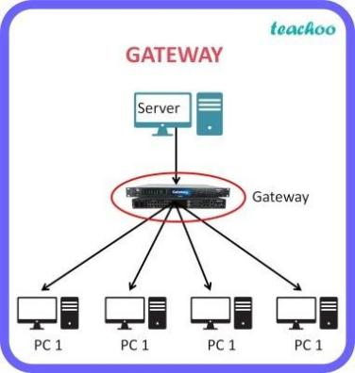

**Study of Transmission Media**

The below information is given for reference purpose only; you need to replace this with the information you have searched

1. **Twisted pair cable**

In balanced pair operation, the two wires carry equal and opposite signals and the destination detects the difference between the two. This is known as differential mode transmission. Noise sources introduce signals into the wires by coupling of electric or magnetic fields and tend to couple to both wires equally. The noise thus produces a common-mode signal which is canceled at the receiver when the difference signal is taken.

This method starts to fail when the noise source is close to the signal wires; the closer wire will couple with the noise more strongly and the common-mode rejection of the receiver will fail to eliminate it. This problem is especially apparent in telecommunication cables where pairs in the same cable lie next to each other for many miles. One pair can induce crosstalk in another and it is additive along the length of the cable. Twisting the pairs counters this effect as on each half twist the wire nearest to the noise-source is exchanged.

Provided the interfering source remains uniform or nearly so, over the distance of a single twist, the induced noise will remain common-mode. Differential signalling also reduces electromagnetic radiation from the cable, along with the associated attenuation allowing for greater distance between exchanges.

The twist rate (also called pitch of the twist, usually defined in twists per meter) makes up part of the specification for a given type of cable. Where nearby pairs have equal twist rates, the same conductors of the different pairs may repeatedly lie next to each other, partially undoing the benefits of differential mode. For this reason it is commonly specified that, at least for cables containing small numbers of pairs, the twist rates must differ.[

UTP cables are found in many Ethernet networks and telephone systems. For indoor telephone applications, UTP is often grouped into sets of 25 pairs according to a standard 25-pair color code originally developed by AT&T Corporation. A typical subset of these colors (white/blue, blue/white, white/orange, orange/white) shows up in most UTP cables. The cables are typically made with copper wires measured at 22 or 24 American Wire Gauge (AWG),[3] with the colored insulation typically made from an insulator such as polyurethane and the total package covered in a polyurethane jacket.

For urban outdoor telephone cables containing hundreds or thousands of pairs, the cable is divided into smaller but identical bundles. Each bundle consists of twisted pairs that have different twist rates. The bundles are in turn twisted together to make up the cable. Pairs having the same twist rate within the cable can still experience some degree of crosstalk. Wire pairs are selected carefully to minimize crosstalk within a large cable.

Unshielded twisted pair cable with different twist rates

UTP cable is also the most common cable used in computer networking. Modern Ethernet, the most common data networking standard, can use UTP cables. Twisted pair cabling is often used in data networks for short and medium length connections because of its relatively lower costs compared to optical fiber and coaxial cable.

UTP is also finding increasing use in video applications, primarily in security cameras. Many cameras include a UTP output with screw terminals; UTP cable bandwidth has improved to match the baseband of television signals. As UTP is a balanced transmission line, a balun is needed to connect to unbalanced equipment, for example any using BNC connectors and designed for coaxial cable.

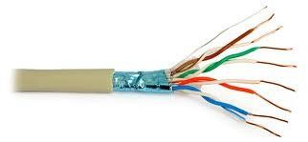

Fig 7.Twisted Pair Cable

1. **Coaxial cable**

Coaxial cable is the kind of copper cable used by cable TV companies between the community antenna and user homes and businesses. Coaxial cable is sometimes used by telephone companies from their central office to the telephone poles near users. It is also widely installed for use in business and corporation Ethernet and other types of local area network.

Coaxial cable is called "coaxial" because it includes one physicalchannel that carries the signal surrounded (after a layer of insulation) by another concentric physical channel, both running along the same axis. The outer channel serves as a ground. Many of these cables or pairs of coaxial tubes can be placed in a single outer sheathing and, with repeaters, can carry information for a great distance.

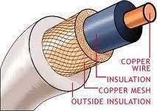

Fig 8.Coaxial Cable

1. **Optical Fiber**

Fiber-optic communication is a method of transmitting information from one place to another by sending pulses of light through an optical fiber. The light forms an electromagnetic carrier wave that is modulated to carry information. First developed in the 1970s, fiber-optic communication systems have revolutionized the telecommunications industry and have played a major role in the advent of the Information Age. Because of its advantages over electrical transmission, optical fibers have largely replaced copper wire communications in core networks in the developed world.

The process of communicating using fiber-optics involves the following basic steps: Creating the optical signal involving the use of a transmitter, relaying the signal along the fiber, ensuring that the signal does not become too distorted or weak, receiving the optical signal, and converting it into an electrical signal.

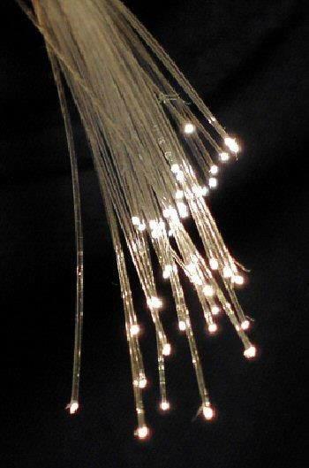

Fig 9.Fiber Optics Cable

**Summary**

The features of the connecting devices and transmission media can be explained in brief as follows:

The experiment focused on studying various networking devices and transmission media essential for modern communication networks.

## Connecting Devices:

* 1. **Hub**: Basic networking device operating at the physical layer (Layer 1), broadcasts data to all connected devices indiscriminately.
  2. **Switch**: Advanced device operating at the data link layer (Layer 2), intelligently forwards data to specific devices based on MAC addresses, enhancing network efficiency by reducing collisions.
  3. **Router**: Network device operating at the network layer (Layer 3), facilitates communication between different networks by forwarding data packets based on IP addresses, enabling connectivity across LANs and WANs.
  4. **Bridge**: Connects and filters data between different network segments at the data link layer (Layer 2), improving network performance and reducing congestion by segmenting large networks.
  5. **Gateway**: Interface device operating at the application layer (Layer 7), translates protocols between different networks, such as LANs and the internet, facilitating seamless communication despite varying communication standards.

## Transmission Media:

* **Twisted Pair Cable**: Utilized in Ethernet networks and telephone systems, effectively reduces electromagnetic interference and crosstalk through twisted pairs of wires.
* **Coaxial Cable**: Commonly employed by cable TV companies and in Ethernet networks, consists of a central conductor surrounded by insulation and a grounded shield, capable of carrying signals over long distances.
* **Optical Fiber**: Uses light pulses transmitted through glass or plastic fibers, offering high bandwidth and low attenuation, making it ideal for long-distance data transmission in telecommunications.

The study underscored the importance of these devices and media in building robust and efficient network infrastructures. Understanding their functionalities and applications is crucial for network designers, administrators, and engineers in optimizing network performance and ensuring reliable connectivity.

**CONCLUSION:** The experiment successfully explored various networking devices including hubs, switches, routers, bridges, and gateways, along with different transmission media such as twisted pair cable, coaxial cable, and optical fiber. Understanding these components is crucial for designing and maintaining efficient networks.

**Post Lab Questions**

* + 1. Compare Hub, switch, bridge, and gateway and specify the use in different cases.

|  |  |  |
| --- | --- | --- |
| **Device** | **Description** | **Typical Use Cases** |
| **Hub** | Simple networking device that connects  multiple Ethernet devices | Small networks with low traffic |
| **Switch** | Device that efficiently forwards data to  specific devices | Larger LANs to reduce collisions  and manage bandwidth |
| **Bridge** | Connects network segments to improve  performance and isolate issues | Dividing LANs into segments to  reduce congestion |
| **Gateway** | Translates protocols between different  networks | Connecting LANs to the internet,  translating protocols |

* + 1. Which of the following device is used to connect two systems, especially if the systems use different protocols?
       1. hub B.bridge C.gateway D.repeater

E.None of the above

# ANSWER : C.gateway

* + 1. Frames from one LAN can be transmitted to another LAN via the device
       1. Router
       2. Bridge
       3. Repeater
       4. Modem

# ANSWER : A.Router